Progress Report 1: Arduino Fundamentals

20220827 Fang Wenqu

2023-03-20

1. How the Breadboard Works

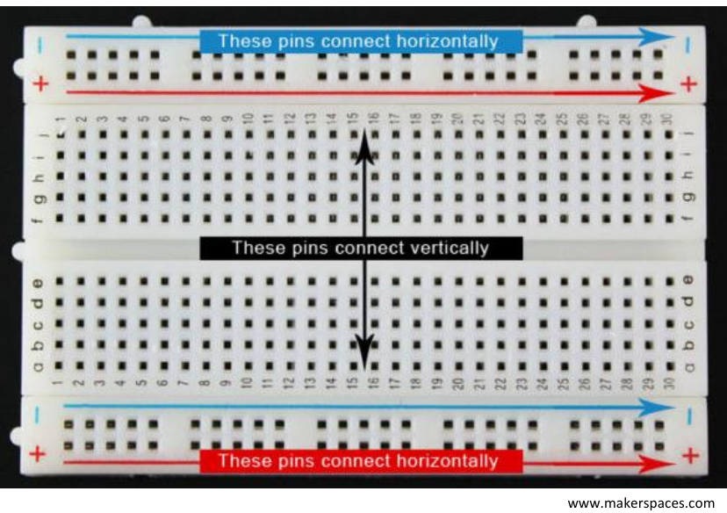

1. LED-Resistor Circuit
   1. Circuit diagram

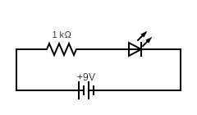

* 1. Implementation

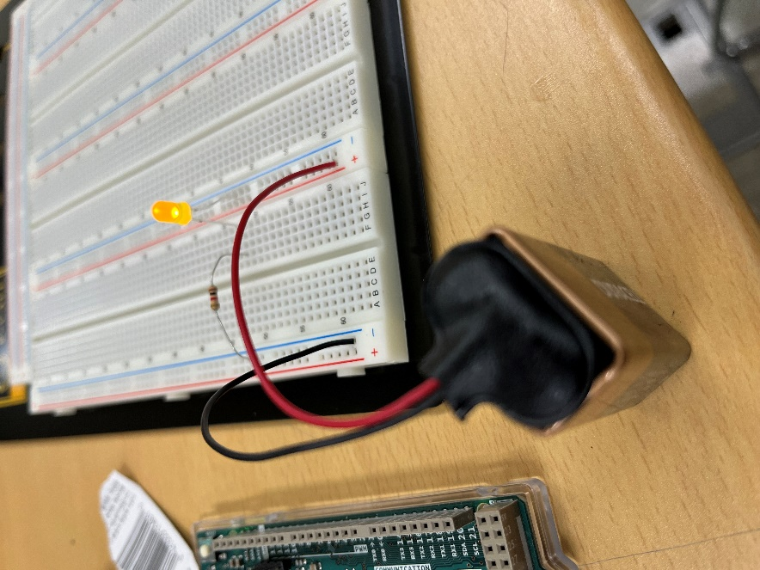

1. 2-LED in Series
   1. Circuit diagram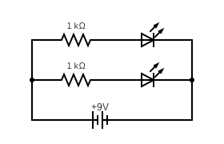
   2. Implementation

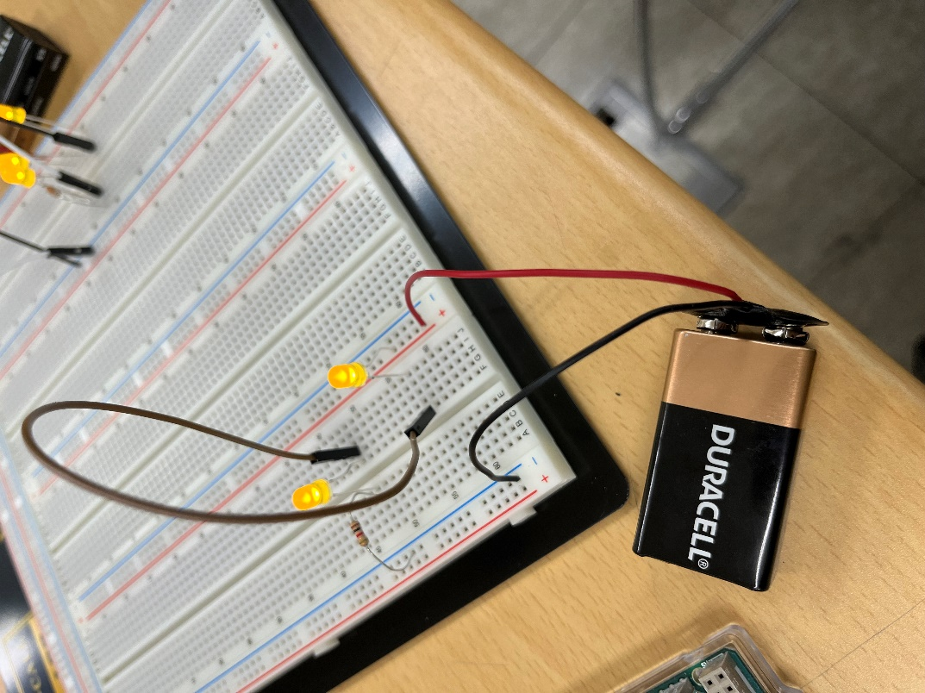

1. 3-LED in Parallel
   1. Circuit diagram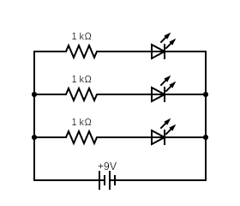
   2. Implementation

